Equations of Circles
Exercise 1 – Using equation of circle
Question 1: Write down the equation of each of these circles:
- Centre (0,3) radius 2.
- Centre (1, -5) radius 4
- Centre (-3, 4) radius $\sqrt{7}$
- Centre (8, 15) radius 17
Does the circle pass through the origin? Show working to support your answer.
Question 2: Write down the centre and radius of each of these circles.
- $x^{2}+y^{2}=36$
- ${\left(x-3\right)}^{2}+{\left(y-4\right)}^{2}=100$
- ${\left(x+5\right)}^{2}+y^{2}=3$
Question 3: Determine whether the point $A$ lies on each of these circles.
- $A\left(1,1\right)$ on $x^{2}+{\left(y+2\right)}^{2}=10$
- $A(4,7)$ on ${\left(x-1\right)}^{2}+{\left(y-2\right)}^{2}=9$
Question 4: [AQA] A circle has equation ${\left(x-5\right)}^{2}+{\left(y-4\right)}^{2}=100$
Show that the point $\left(13,-2\right)$ lies on the circle.
Question 5: [AQA] The point $\left(13,-2\right)$ lies on the circle ${\left(x-a\right)}^{2}+{\left(y-4\right)}^{2}=100$
Work out the two possible values of $a$.
Question 6: [Jan 2013 Paper 2] Match each statement with an equation. You will not use all the equations.
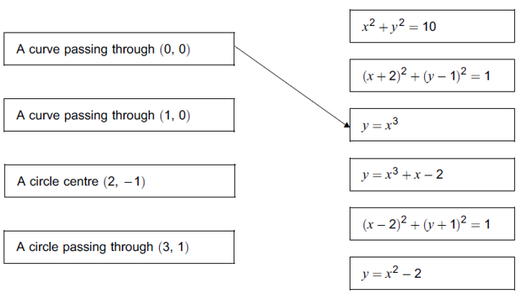
Question 7: [Jan 2012 Paper 2] A circle has the equation $x^{2}+y^{2}=36$. Work out its circumference.

Question 8: [June 2013 Paper 2] The circle $x^{2}+y^{2}=25$ touches each side of the square as shown. Work out the total shaded area.
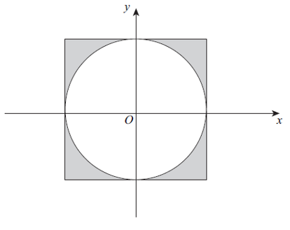
Question 9: [AQA]
Circle A has equation: $x^{2}+y^{2}=16$
Circle $B$ has equation ${\left(x+6\right)}^{2}+{\left(y-8\right)}^{2}=25$
(a) Work out the distance between the centres of the circles.
(b) Circle the correct statement:
The circles overlap The circles touch
The circles do not overlap
Question 10: Determine the coordinates of the points where the circle with equation:
$${\left(x+5\right)}^{2}+{\left(y-12\right)}^{2}=169$$intercepts either axis.
Question 11: Determine the points $A$ and $B$ where the circle with equation:
$${\left(x-4\right)}^{2}+{\left(y+3\right)}^{2}=100$$intersects the line with equation $x=12$. Hence determine the length $AB$.

Exercise 2 – Determining Centre/Radius
Question 1: [AQA] $AB$ is the diameter of a circle. $A$ is $\left(-3,6\right)$ and $B$ is $\left(5,12\right)$. Work out the equation of the circle.
Question 2: [AQA] $PQ$ is a diameter of a circle, centre $C$.
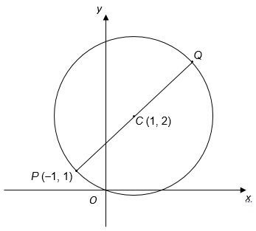
(a) Work out the coordinates of $Q$.
(b) Work out the equation of the circle.
Question 3: [AQA] $A(12, 6)$ and $B(14, 4)$ are two points on a circle, centre $C\left(20, 12\right)$.
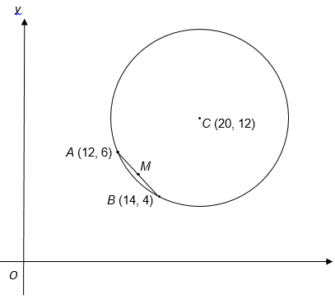
- Work out the coordinates of the midpoint $M$ of $AB$.
- Show that the length $CM=7\sqrt{2}$
- Work out the radius of the circle.
Question 4: [AQA] (0, -2), (0, 12) and (4, 12) are three points on a circle, centre $C$. Work out the coordinate of $C$.
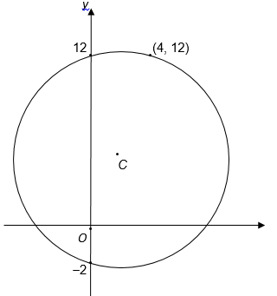
Question 5: [June 2013 Paper 1 Q2] A is (-4,3) and B is (2,11). AB is a diameter of the circle.
- Work out the coordinates of the centre of the circle.
- Work out the radius of the circle.
- Write down the equation of the circle.
- P is another point on the circle. The gradient of the line $AP$ is 2. Write down the gradient of the line $PB$.
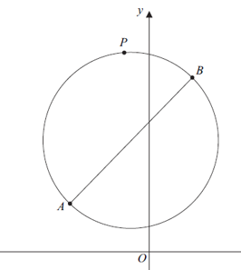
Question 6: [June 2012 Paper 2 Q14] The sketch shows a circle, centre C, radius 5. The circle passes through the points A(-2,8) and B(6,8). The $x$-axis is a tangent to the circle.
Work out the equation of the circle.
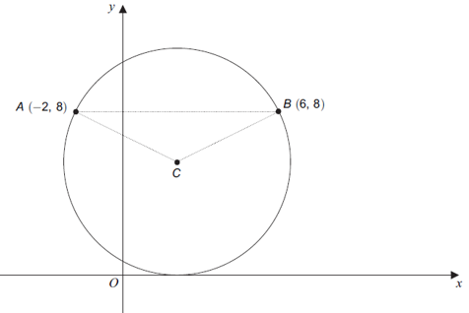
Question 7: A circle passes through the points (0,3) and (0,11) and has centre (6,k).
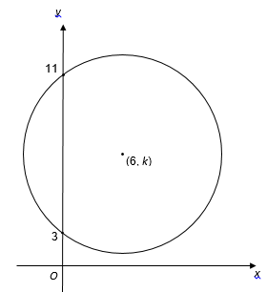
- Work out the value of $k$.
- Hence find the equation of the circle.

Question 8: AB is a diameter of the circle ABC. Work out the value of $k$. (Hint: What do you know about the line AC relative to CB? Can you find an equation of the line CB?)
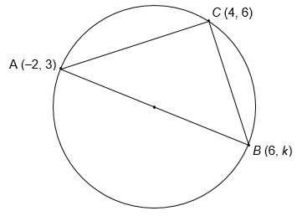

Question 9: ABCD is a square. $A$ is the point (5,13). $C$ is the point (5,5). The circle touches the sides of the square. Work out the equation of the circle.
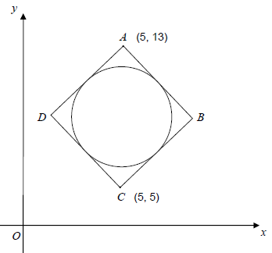

Exercise 3 – Perpendicular lines
Question 1: [AQA Practice Paper] The sketch show point $P$ on a circle, centre C. The equation of the tangent at P is $y=13-2x$.
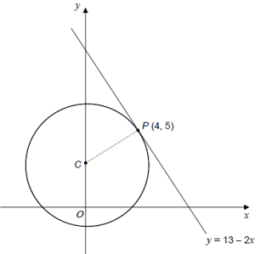
- Work out the gradient of PC.
- Work out the equation of the circle.
Question 2: [AQA Practice Paper] The sketch shows part of a circle, centre C, that intersects the axes at points $P, Q$ and $R$.
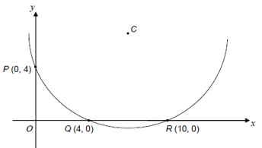
- Explain why the centre of the circle lies on the line $x=7$
- Show that the line $y=x$ is the perpendicular bisector of the line $PQ$.
- Work out the equation of the circle.
Question 3: The points $A(3,5)$ and $B\left(10,k\right)$ form a diameter of a circle. The point $C\left(9,8\right)$ is another point on the circle.
- Determine the gradient of the line $AC$.
- Hence determine the equation of the line $CB$.
- Hence, given that the point $B$ lies on this line, determine the value of $k$.
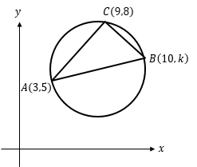
Question 4: The diagram shows points $A\left(4,3\right), B(10,5)$ and $C(12,q)$. $C$ is the centre of the circle and $AB$ form a chord of the circle. $M$ is the midpoint of $AB$.
- Determine the gradient of $AB$ and the coordinate of $M$.
- Hence find the equation of $MC$.
- Hence determine the value of $q$.
- Find the equation of the circle.
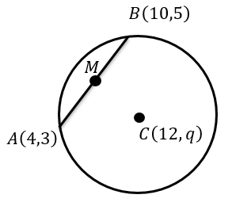
Question 5: A line with equation $y=4x-13$ is tangent to a circle at the point $P\left(5,7\right)$.
- Determine the equation of $PC$.
- Determine the value of $k$.
- Hence determine the equation of the circle.
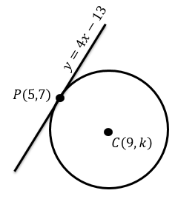
Question 6: The points $A\left(3,5\right)$ and $B\left(6,14\right)$ lie on the circumference of a circle, and $B$ is at the top of the circle. Determine:
- The centre of the circle.
- The equation of the circle.
