IGCSE Further Maths Geometric Proofs Exercise
[Test Your Understanding]
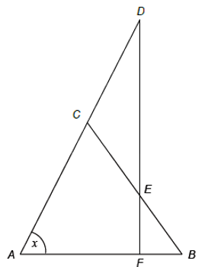
Triangle $ABC$ is isosceles with $AC=BC$.
Triangle $CDE$ is isosceles with $CD=CE$.
$ACD$ and $DEF$ are straight lines.
- Prove that angle $DCE=2x$
- Prove that $DF$ is perpendicular to $AB$.

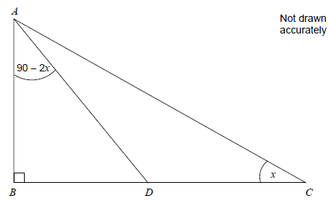
Question 1 [Set 4 Paper 1 Q4]
$ABC$ is a right-angled triangle. Angle $ACB=x$. Angle $BAD=90-2x$.
Prove that $ACD$ is an isosceles triangle.

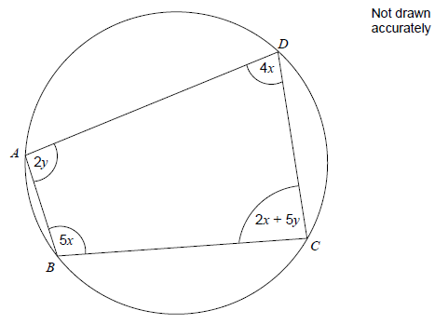
Question 2 [Set 4 Paper 1 Q9]
$ABCD$ is a quadrilateral.
Prove that $x=y$.

Question 3 [Set 4 Paper 2 Q3]
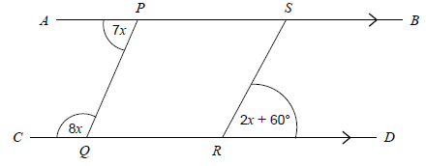
$AB$ is parallel to $CD$.
Is $PQ$ parallel to $SR$? You must show your working.

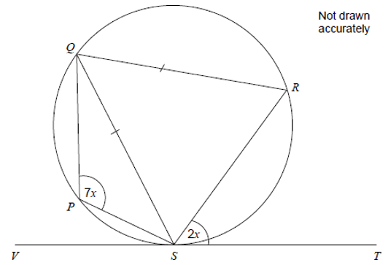
Question 4 [Set 4 Paper 2 Q13]
$PQRS$ is a cyclic quadrilateral. $QS=QR$. $VST$ is a tangent to the circle.
Work out the value of $x$. You must show your working.

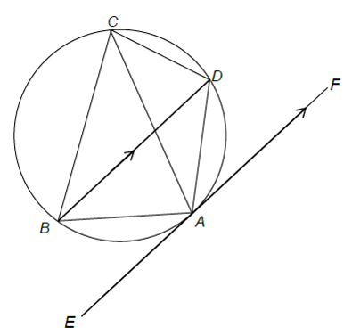
Question 5 [Specimen Paper 1 Q15]
$A$, $B$, $C$ and $D$ are points on the circumference of a circle such that $BD$ is parallel to the tangent to the circle at $A$.
Prove that $AC$ bisects angle $BCD$. Give reasons at each stage of your working.

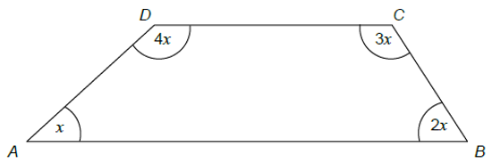
Question 6 [Specimen Paper 2 Q7]
Prove that $AB$ is parallel to $DC$.

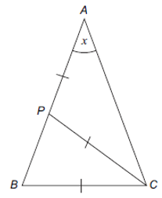
Question 7 [June 2012 Paper 2 Q5]
$ABC$ is a triangle. $P$ is a point on $AB$ such that $AP=PC=BC$. Angle $BAC=x$.
- Prove that angle $ABC=2x$.
- You are also given that $AB=AC$. Work out the value of $x$.

