**Exercise 1 – Sketching Quadratics**

1. Sketch the following parabolas, ensuring you indicate any intersections with the coordinate axes. If the graph has no roots, indicate the minimum/maximum point.  
   (a) $y=x^{2}-2x$  
   (b) $y=x^{2}+4x-5$  
   (c) $y=x^{2}-2x+1$  
   (d) $y=3-x^{2}$  
   (e) $y=4+3x-x^{2}$
2. Sketch the following parabolas. These have no roots, so complete the square to identify the minimum/maximum point.  
   (a) $y=x^{2}+2x+6$  
   (b) $y=x^{2}-4x+7$
3. Find equations for the following graphs, giving your answer in the form $$ax^{2}+bx+c=0$$  
   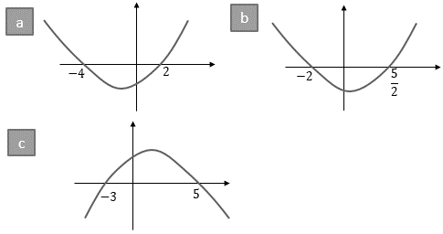

**4. [C1 May 2010 Q4]**(*a*) Show that *x*2 + 6*x* + 11 can be written as

(*x* + *p*)2 + *q*,

where *p* and *q* are integers to be found. **(2)**

(*b*) Sketch the curve with equation   
*y* = *x*2 + 6*x* + 11, showing clearly any intersections with the coordinate axes.

**(2)**

(*c*) Find the value of the discriminant of   
*x*2 + 6*x* + 11. **(2)**

**5.** [AQA] The diagram shows a quadratic graph that intersects the $x$-axis when $x=\frac{1}{2}$ and $x=5$  
.  
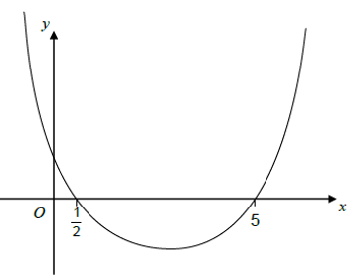  
Work out the equation of the quadratic graph, giving your answer in the form $y=ax^{2}+bx+c$  
 where $a,b,c$ are integers.

**6.** [Set 2 Paper 2] Here is a sketch of $$y=10+3x-x^{2}$$  
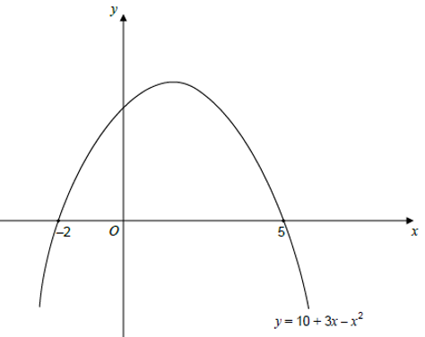(a) Write down the two solutions of $$10+3x-x^{2}=0$$  
(b) Write down the equation of the line of symmetry of $y=10+3x-x^{2}$

**7.** A parabola has a maximum point of $\left(2,-4\right)$.  
(a) Given the quadratic equation is of the form $y={-x}^{2}+ax+b$, determine $a$ and $b$.  
(b) Determine the discriminant.

**Exercise 2 – Sketching Cubics**

1. [Set 1 Paper 2] Sketch the curve $$y=x^{3}-12x^{2}$$
2. Sketch the following, indicating where the lines intersect/touch any axis.  
   (a) $y=x(2x-1)(x+3)$  
   (b) $y=x^{2}(x+1)$  
   (c) $y={\left(x+2\right)}^{3}$  
   (d) $y=\left(2-x\right){\left(x+3\right)}^{2}$

**3.** [Set 4 Paper 2] A sketch of $y=f(x)$, where $f(x)$ is a cubic function, is shown.  
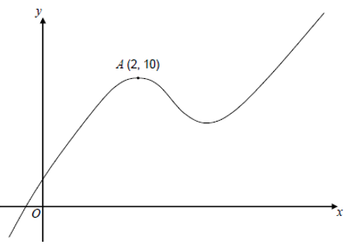  
There is a maximum point at $A\left(2,10\right)$.  
(a) Write down the equation of the tangent to the curve at $A$.  
(b) Write down the equation of the normal to the curve at $A$.

**4.** [Set 2 Paper 2] Here is a sketch of $$x^{3}+bx^{2}+cx+d$$  
where $b,c,d$ are constants.  
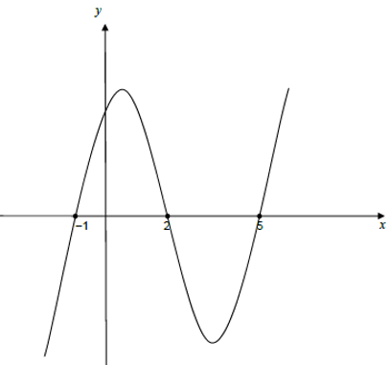  
Work out the values of $b,c,d$.

**5.**  **[C1 May 2013 Q8]**  
Figure 1 shows a sketch of the curve with equation *y* = f(*x*) where

f(*x*) = (*x* + 3)2 (*x* – 1), *x* ∈ℝ.

The curve crosses the *x-*axis at (1, 0), touches it at (–3, 0) and crosses the *y-*axis at (0, –9).

(*a*) Sketch the curve *C* with equation   
*y* = f(*x* + 2) and state the coordinates of the points where the curve *C* meets the *x-*axis. **(3)**

(*b*) Write down an equation of the curve *C*.**(1)**

(*c*) Use your answer to part (*b*) to find the coordinates of the point where the curve *C* meets the *y*-axis. **(2)**

**6.** Suggest equations for the following cubic graphs. (You need not expand out any brackets)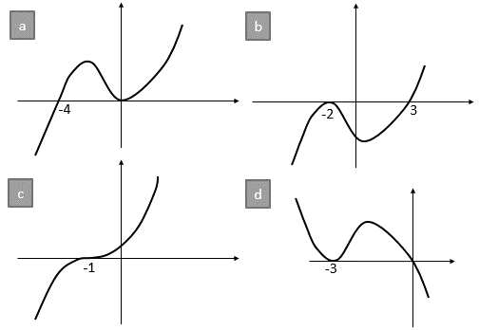

**7. [C1 May 2010 Q10]**(*a*) Sketch the graphs of

(i) *y* = *x* (4 – *x*),

(ii) *y* = *x*2 (7 – *x*),

showing clearly the coordinates of the points where the curves cross the coordinate axes. **(5)**

(*b*) Show that the *x*-coordinates of the points of intersection of

*y* = *x* (4 – *x*) and *y* = *x*2 (7 – *x*)

are given by the solutions to the equation *x*(*x*2 – 8*x* + 4) = 0. **(3)**

The point *A* lies on both of the curves and the *x* and *y* coordinates of *A* are both positive.

(*c*) Find the exact coordinates of *A*, leaving your answer in the form (*p* + *q*√3, *r* + *s*√3), where *p*, *q*, *r* and *s* are integers. **(7)**

**Exercise 3 – Reciprocal Graphs**

**1.** Sketch the following, ensuring you indicate the equation of any asymptotes and the coordinates of any points where the graph crosses the axes.  
(a) $y=\frac{1}{x}-2$ (b) $y=\frac{3}{x}+1$  
(c) $y=\frac{2}{x+1}$ (d) $y=-\frac{1}{x-2}$  
(e) $y=\frac{2}{x+3}-1$

**2.** **[C1 Jan 2007 Q3]** Given that $f\left(x\right)=\frac{1}{x}+3$, *x* ≠ 0,

(*a*) sketch the graph of *y* = f(*x*) and state the equations of the asymptotes. **(4)**

(*b*) Find the coordinates of the point where *y* = f(*x*) crosses a coordinate axis.**(2)**

**3. [C1 Jan 2013 Q6]**  
  
Figure 1 shows a sketch of the curve with equation $y=\frac{2}{x}, x≠0$.

The curve *C* has equation $y=\frac{2}{x}-5, x≠0$, and the line *l* has equation *y* = 4*x* + 2.

(*a*) Sketch and clearly label the graphs of *C* and *l* on a single diagram. On your diagram, show clearly the coordinates of the points where *C* and *l* cross the coordinate axes. **(5)**

(*b*) Write down the equations of the asymptotes of the curve *C*. **(2)**

(*c*) Find the coordinates of the points of intersection of $y=\frac{2}{x}-5$ and *y* = 4*x* + 2. **(5)**

**4. [C1 Jan 2011 Q10]**(*a*) Sketch the graphs of

(i) *y* = *x*(*x* + 2)(3 − *x*),

(ii) $y=-\frac{2}{x}$.

showing clearly the coordinates of all the points where the curves cross the coordinate axes. **(6)**

(*b*) Using your sketch state, giving a reason, the number of real solutions to the equation

*x*(*x* + 2)(3 – *x*) +  = 0. **(2)**

**Exercise 4 – Piecewise Functions**

1. [Jan 2013 Paper 2] A function $f(x)$ is defined as:
$$f\left(x\right)=\left\{\begin{matrix}4 & x<-2 \\ x^{2} & -2≤x≤2 \\ 12-4x & x>2\end{matrix}\right.$$

2. Draw the graph of $y=f(x)$ for $-4≤x≤4$

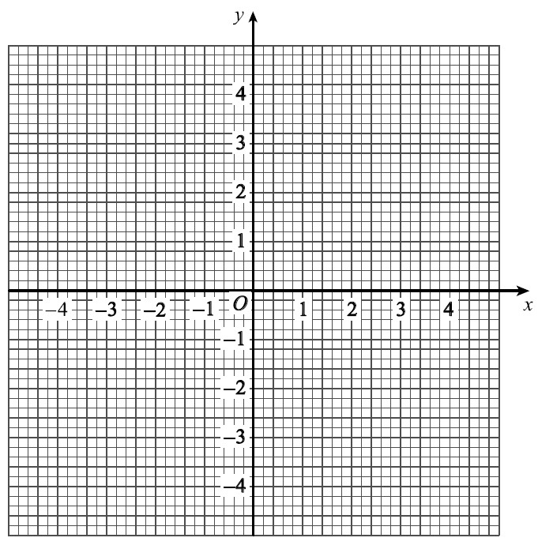

1. Use your graph to write down **how many** solutions there are to $f\left(x\right)=3$
2. Solve $f\left(x\right)=-10$
3. [June 2013 Paper 2] A function $f(x)$ is defined as:

$$f\left(x\right)=\left\{\begin{matrix}x+3 & -3≤x<0 \\ 3 & 0≤x<1 \\ 5-2x & 1≤x≤2\end{matrix}\right.$$

Draw the graph of $y=f(x)$ for $$-3≤x<2$$

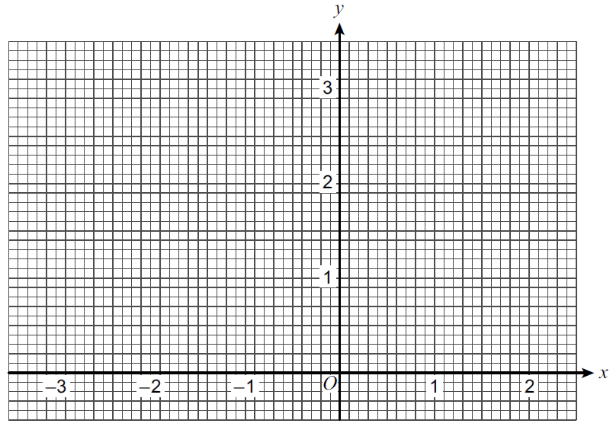

1. [Set 1 Paper 1] A function $f(x)$ is defined as:

$$f\left(x\right)=\left\{\begin{matrix}3 & 0≤x<2 \\ x+1 & 2≤x<4 \\ 9-x & 4≤x≤9\end{matrix}\right.$$

Draw the graph of $y=f(x)$ for $0≤x≤9$.

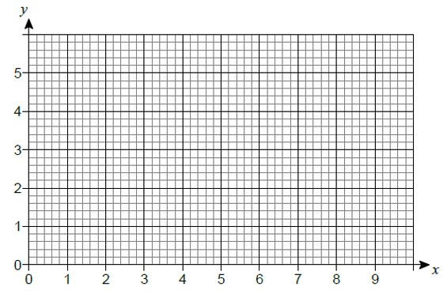

1. [Specimen 1 Q4] A function $f(x)$ is defined as:

$$f\left(x\right)=\left\{\begin{matrix}3x & 0≤x<1 \\ 3 & 1≤x<3 \\ 12-3x & 3≤x≤4\end{matrix}\right.$$

Calculate the area enclosed by the graph of $y=f\left(x\right)$ and the $x-$ axis.

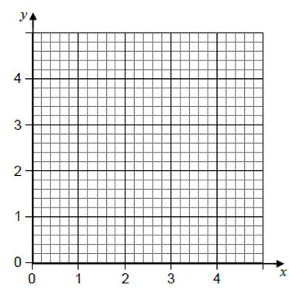

1. [AQA Worksheet Q9] $$f\left(x\right)=\left\{\begin{matrix}-x^{2} & 0≤x<2 \\ -4 & 2≤x<3 \\ 2x-10 & 3≤x≤5\end{matrix}\right.$$

Draw the graph of $f(x)$ from $0≤x≤5$.

1. [AQA Worksheet Q10]

$$f\left(x\right)=\left\{\begin{matrix}2x & 0≤x<1 \\ 3-x & 1≤x<4 \\ \frac{x-7}{3} & 4≤x≤7\end{matrix}\right.$$

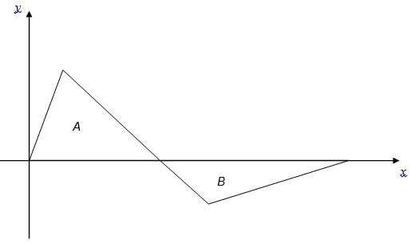

Show that $area of A:area of B=3:2$

**Exercise 5 – Graph Transformations**

**TYU.** (*a*) Factorise completely *x*3 – 6*x*2 + 9*x* **(3)**

(*b*) Sketch the curve with equation

*y* = *x*3 – 6*x*2 + 9*x*

showing the coordinates of the points at which the curve meets the *x*-axis. **(4)**

Using your answer to part (*b*), or otherwise,

(*c*) sketch, on a separate diagram, the curve with equation

*y* = (*x –* 2)3 – 6(*x –* 2)2 + 9(*x –* 2)

showing the coordinates of the points at which the curve meets the *x*-axis. **(2)**

**1. [C1 Jan 2011 Q5]**

**

**Figure 1**

Figure 1 shows a sketch of the curve with equation *y* = f(*x*) where

f(*x*) = , *x* ≠ 2.

The curve passes through the origin and has two asymptotes, with equations *y* = 1 and *x* = 2, as shown in Figure 1.

(*a*) Sketch the curve with equation *y* = f(*x* − 1) and state the equations of the asymptotes of this curve. **(3)**

(*b*) Find the coordinates of the points where the curve with equation *y* = f(*x* − 1) crosses the coordinate axes. **(4)**

**2.** **[C1 May 2010 Q6]**



Figure 1 shows a sketch of the curve with equation *y* = f(*x*). The curve has a maximum point *A* at (–2, 3) and a minimum point *B* at (3, – 5). On separate diagrams sketch the curve with equation

(*a*) *y* = f (*x* + 3), **(3)**

(*b*) *y* = 2f(*x*). **(3)**

On each diagram show clearly the coordinates of the maximum and minimum points.

The graph of *y* = f(*x*) + *a* has a minimum at (3, 0), where *a* is a constant.

(*c*) Write down the value of *a*.

**(1)**

**3.** **[C1 May 2011 Q8]**



Figure 1 shows a sketch of the curve *C* with equation *y* = f(*x*). The curve *C* passes through the origin and through (6, 0). The curve *C* has a minimum at the point (3, –1).

On separate diagrams, sketch the curve with equation

(*a*) *y* = f(2*x*), **(3)**

(*b*) *y* = −f(*x*), **(3)**

(*c*) *y* = f(*x* + *p*), where 0 < *p* < 3. **(4)**

On each diagram show the coordinates of any points where the curve intersects the *x*-axis and of any minimum or maximum points.

**4. [C1 May 2012 Q10]**



**Figure 1**

Figure 1 shows a sketch of the curve *C* with equation *y* = f(*x*), where

f(*x*) = *x*2(9 – 2*x*).

There is a minimum at the origin, a maximum at the point (3, 27) and *C* cuts the *x*-axis at the point *A*.

(*a*) Write down the coordinates of the point *A*.

(*b*) On separate diagrams sketch the curve with equation

1. *y* = f(*x* + 3),

(ii) *y* = f(3*x*).

On each sketch you should indicate clearly the coordinates of the maximum point and any points where the curves cross or meet the coordinate axes.

The curve with equation *y* = f(*x*) + *k*, where *k* is a constant, has a maximum point at (3, 10).

(*c*) Write down the value of *k*.

**5. [Jan 2010 Q8]**

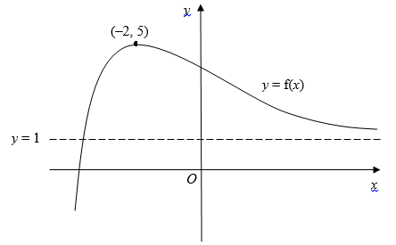

Figure 1 shows a sketch of part of the curve with equation *y* = f(*x*).

The curve has a maximum point (–2, 5) and an asymptote *y* = 1, as shown in Figure 1.

On separate diagrams, sketch the curve with equation

(*a*) *y* = f(*x*) + 2, **(2)**

(*b*) *y* = 4f(*x*), **(2)**

(c) *y* = f(*x* + 1). **(3)**

On each diagram, show clearly the coordinates of the maximum point and the equation of the asymptote.

**6. [C1 June 2008 Q3]  
**

Figure 1 shows a sketch of the curve with equation *y* = f(*x*). The curve passes through the point (0, 7) and has a minimum point at (7, 0).

On separate diagrams, sketch the curve with equation

(*a*) *y* = f(*x*) + 3, **(3)**

(*b*) *y* = f(2*x*). **(2)**

On each diagram, show clearly the coordinates of the minimum point and the coordinates of the point at which the curve crosses the *y*-axis.