Trigonometry II – 3D Pythagoras and Trigonometry

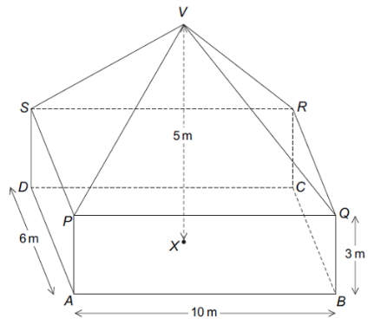Test Your Understanding
[AQA Jan 2013 Paper 2] The diagram shows a cuboid $ABCDPQRS$ and a pyramid $PQRSV$. $V$ is directly above the centre $X$ of $ABCD$.
a) Work out the angle between the line $VA$ and the plane $ABCD$. (Reminder: ‘Drop’ $VA$ onto the plane)
b) Work out the angle between the planes $VQR$ and $PQRS$.
Exercise 2
- A cube has sides 8cm. Find:
a) The length $AB$.
b) The angle between $AB$ and the horizontal plane.
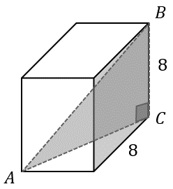
- A radio tower 150m tall has two support cables running 300m due East and some distance due South, anchored at $A$ and $B$. The angle of inclination to the horizontal of the latter cable is $50°$ as indicated.
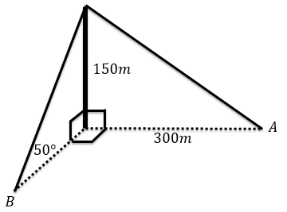
a) Find the angle between the cable attached to $A$ and the horizontal plane.
b) Find the distance between $A$ and $B$.
- Frost Manor is as pictured, with $EFGH$ horizontally level.
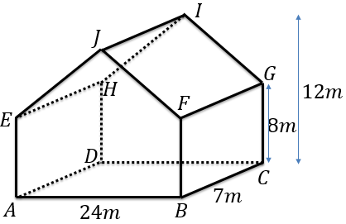
a) Find the angle between the line $AG$ and the plane $ABCD$.
b) Find the angle between the planes $FGIJ$ and $EFGH$.
- A school buys a set of new ‘extra comfort’ chairs with its seats pyramid in shape. $X$ is at the centre of the base of the pyramid, and $M$ is the midpoint of $BC$.
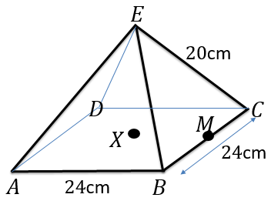
a) By considering the triangle $EBC$, find the length $EM$. 16cm
b) Hence determine the angle between the triangle $EBC$ and the plane $ABCD$.
- [June 2013 Paper 2] $ABCDEFGH$ is a cuboid. $M$ is the midpoint of $HG$. $N$ is the midpoint of $DC$.
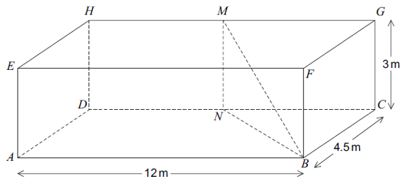
- Show that $BN=$ 7.5m
- Work out the angle between the line $MB$ and the plane $ABCD$.
- Work out the obtuse angle between the planes $MNB$ and $CDHG$.

- [Set 3 Paper 2] The diagram shows part of a skate ramp, modelled as a triangular prism.
$ABCD$ represents horizontal ground. The vertical rise of the ramp, $CF$, is 7 feet. The distance $BC=24$ feet.
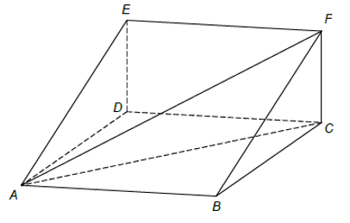
You are given that
$$gradient=\frac{vertical rise}{horizontal distance}$$
a) The gradient of $BF$ is twice the gradient of $AF$. Write down the distance $AC$.
b) Greg skates down the ramp along $FB$. How much further would he travel if he had skated along $FA$.

- 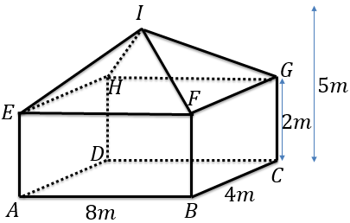
a) Determine the angle between the line $AI$ and the plane $ABCD$.
b) Determine the angle between the planes $FHI$ and $EFGH$.
- A ‘truncated pyramid’ is formed by slicing off the top of a square-based pyramid, as shown. The top and bottom are two squares of sides 2 and 4 respectively and the slope height 3.
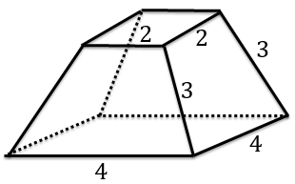
Find the angle between the sloped faces with the bottom face.
- 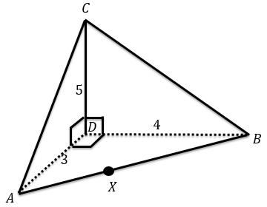a) $X$ is a point on $AB$ such that $XC$ is the line of greatest slope on the triangle $ABC$. Determine the length of $AX$.
b) Hence determine $DX$.
c) Hence find the angle between the planes $ABC$ and $ABD$.

Exercise 3
- [June 2012 Paper 2 Q13]
Work out angle $x$.
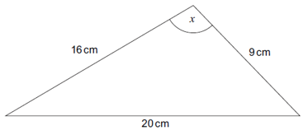
- Here is a triangle. Work out $θ$.
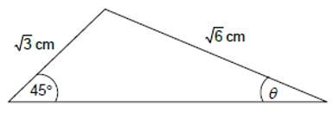
- Use the cosine rule to determine $x$.
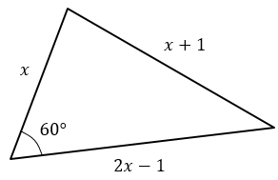
- Given that the area of the triangle is 24cm². Find the values of $x$ and $y$.
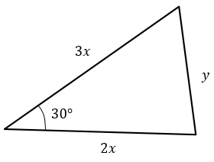
- The angle $θ$ is obtuse. Determine $θ$.
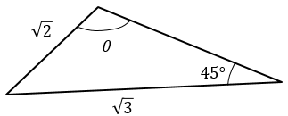
- [June 2012 Paper 1] Triangle ABC has an obtuse angle at C. Given that $\sin{A}=\frac{1}{4}$, use triangle $ABC$ to show that angle $B=60°$.
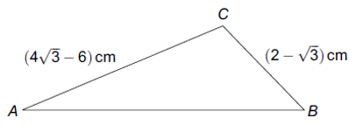
- [June 2013 Paper 2 Q23] In triangle $ABC$, $AP$ bisects angle $BAC$.
Use the sine rule in triangles $ABP$ and $ACP$ to prove that $\frac{AB}{AC}=\frac{BP}{PC}$.
