**IGCSEFM/C1 Tangent/Normal Questions**

**IGCSE Questions**

1. [IGCSEFM June 2012 Paper 1 Q8] A curve has equation $y=x^{3}+5x^{2}+1$  
   (a) When $x=-1$, show that the value of $\frac{dy}{dx}$ is -7.  
   (b) Work out the equation of the tangent to the curve $y=x^{3}+5x^{2}+1$ at the point where $x=-1$.
2. [IGCSEFM June 2013 Paper Q8] A curve has equation $y=x^{4}-5x^{2}+9$  
   (a) Work out $\frac{dy}{dx}$.  
   (b) Work out the equation of the tangent to the curve at the point where $x=2$  
   Give your answer in the form $y=mx+c$
3. [IGCSEFM Set Paper 1 Q11] Show that the tangents to the curve $y=x^{3}+3x^{2}+3x+1$ at $x=1$ and $x=-3$ are parallel.
4. [IGCSEFM Set 1 Paper 2 Q17] Work out the equation of the normal to the curve $y=2x^{3}-x^{2}+1$ at the point (1, 2). Give your answer in the form $y=mx+c$.
5. [IGCSEFM Set 2 Paper 1 Q15] The graph shows a sketch of $y=(x-2)(x-3)$. The curve intersects the $x$-axis at $P$ and $Q$.  
   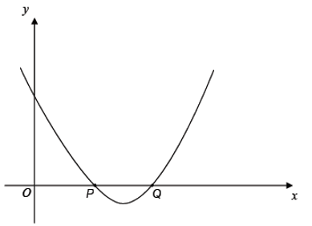  
   Show that the tangents at $P$ and $Q$ are perpendicular.
6. [IGCSEFM Set 4 Paper 2 Q20] A sketch of the curve $y=(x+1)(2-x)$ is shown. $A\left(0,2\right), P(2,0)$ 
    and $Q$ are points on the curve.  
   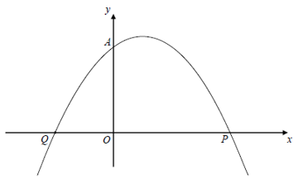  
   (a) Write down the coordinates of point $Q$.  
   (b) Show that the normal to the curve at $A$ intersects the curve again at $P$.
7. [IGCSEFM Specimen Paper 2 Q22] The diagram shows the graph of $y=x^{2}-4x+3$  
   The curve cuts the $x$-axis at the points $A$ and $B$.  
   The tangent to the curve at the point (5,8) cuts the $x$-axis at the point $C$.  
   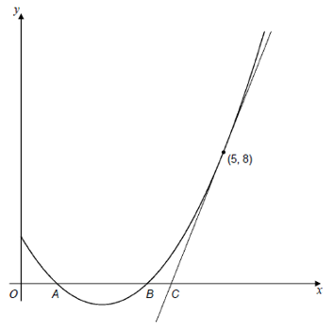  
   Show that $AB=3BC$.

**C1 Questions**

**[Jan 2013 Q11]**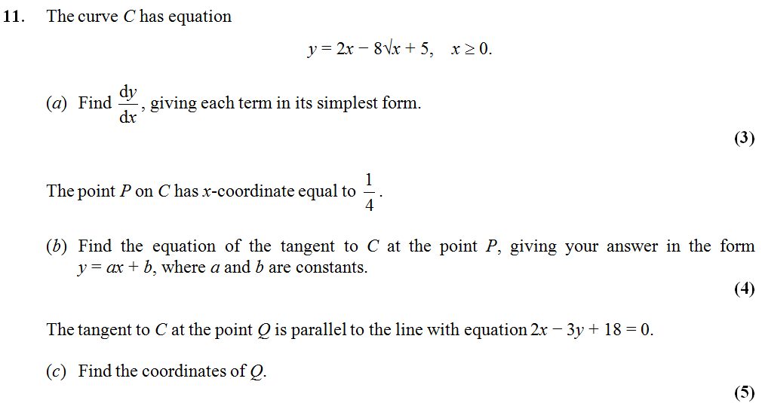

**[June 2011 Q10]**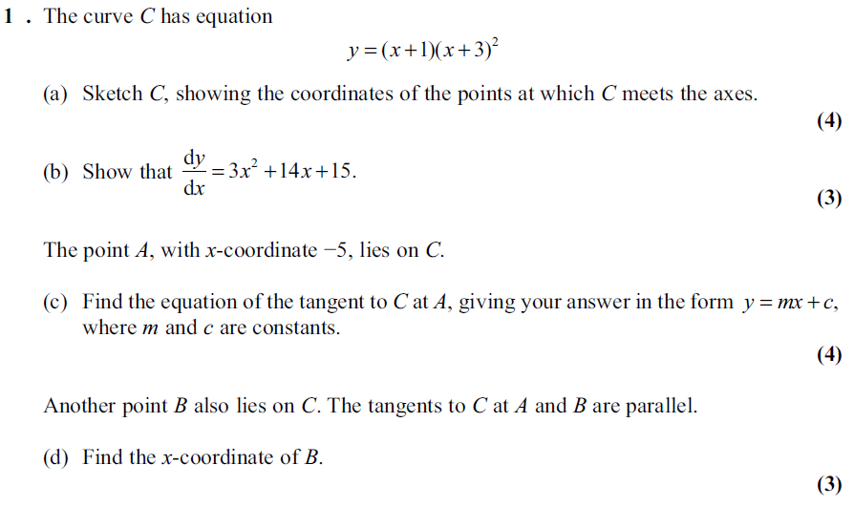

**[Jan 2012 Q10]**

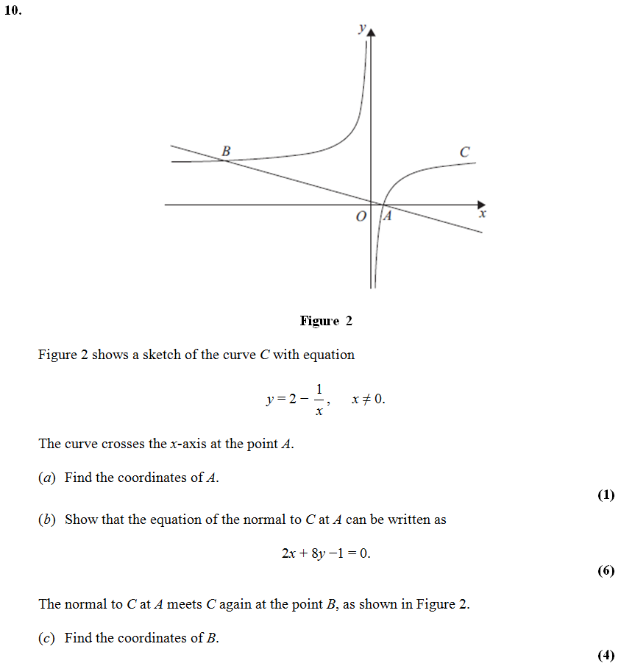

**[Jan 2011 Q11] 11.** The curve *C* has equation

*y* =  –  +  + 30, *x* > 0.

(*a*) Find .

**(4)**

(*b*) Show that the point *P*(4, –8) lies on *C*.

**(2)**

(*c*) Find an equation of the normal to *C* at the point *P*, giving your answer in the form *ax*+ *by*+ *c* = 0 , where a, b and c are integers.

**(6)**