Functions, Domain and Range
Exercise 1
1. [AQA Worksheet] $f\left(x\right)=2x^{3}-250$. Work out $x$ when $f\left(x\right)=0$
2. [AQA Worksheet] $f\left(x\right)=x^{2}+ax-8$.
If $f\left(-3\right)=13$, determine the value of $a$.
3. [AQA Worksheet] $f\left(x\right)=x^{2}+3x-10$
Show that $f\left(x+2\right)=x\left(x+7\right)$
4. [June 2012 Paper 2] $f\left(x\right)=3x-5$ for all values of $x$. Solve $f\left(x^{2}\right)=43$
5. [AQA Set 2] The function $f(x)$ is defined as
$$f\left(x\right)=\left\{\begin{matrix}x^{2}-4 & 0≤x<3 \\ 14-3x & 3≤x≤5\end{matrix}\right.$$(a) Work out the value of $f(1)$
(b) Work out the value of $f(4)$
(c) Solve $f\left(x\right)=0$
6. If $f\left(x\right)=2x-1$ determine:
(a) $f(2x)$
(b) $f\left(x^{2}\right)$
(c) $f\left(2x-1\right)$
(d) $f\left(1+2f\left(x-1\right)\right)$
(e) Solve $f\left(x+1\right)+f\left(x-1\right)=0$

Exercise 2
- [AQA Worksheet] Work out the range for each of these functions.
(a) $f\left(x\right)=x^{2}+6$ for all $x$
(b) $f\left(x\right)=3x-5, -2≤x≤6$
(c) $f\left(x\right)=3x^{4}, x<-2$
- [AQA Worksheet] (a) $f\left(x\right)=\frac{x+2}{x-3}$
Give a reason why $x>0$ is not a suitable domain for $f(x)$.
(b) Give a possible domain for $f\left(x\right)=\sqrt{x-5}$
- $f\left(x\right)=3-2x, a<x<b$
The range of $f(x)$ is $-5<f\left(x\right)<5$
Work out $a$ and $b$.
- [Set 1 Paper 2] (a) The function $f(x)$ is defined as:
$$f\left(x\right)=22-7x, -2≤x≤p$$The range of $f(x)$ is $-13≤f\left(x\right)≤36$
Work out the value of $p$.
(b) The function $g(x)$ is defined as
$g\left(x\right)=x^{2}-4x+5$ for all $x$.
(i) Express $g(x)$ in the form ${\left(x-a\right)}^{2}+b$
(ii) Hence write down the range of $g(x)$.
- [June 2012 Paper 1] $f\left(x\right)=2x^{2}+7$ for all values of $x$.
(a) What is the value of $f\left(-1\right)$?
(b) What is the range of $f(x)$?
- [Jan 2013 Paper 2]
$$f\left(x\right)=\sin{x} 180°≤x≤360° \\ g\left(x\right)=\cos{x} 0°≤x≤θ$$(a) What is the range of $f(x)$?
(b) You are given that $0≤g\left(x\right)≤1$.
Work out the value of $θ$.
- By completing the square or otherwise, determine the range of the following functions:
(a) $f\left(x\right)=x^{2}-2x+5,$for all $x$
(b) $f\left(x\right)=x^{2}+6x-2,$ for all $x$
- [AQA Worksheet] Here is a sketch of $f\left(x\right)=x^{2}+6x+a$ for all $x$, where $a$ is a constant.
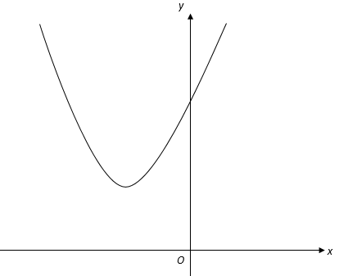
The range of $f(x)$ is $f\left(x\right)≥11$. Work out the value of $a$.
- [Set 3] The straight line shows a sketch of $y=f(x)$ for the full domain of the function.
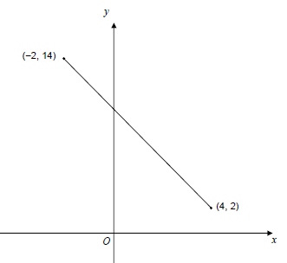
(a) State the domain of the function.
(b) Work out the equation of the line.
- [Set 3] $f(x)$ is a quadratic function with domain all real values of $x$. Part of the graph of $y=f\left(x\right)$ is shown.
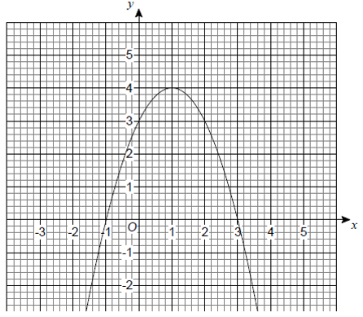
(a) Write down the range of $f(x)$.
(b) Use the graph to find solutions of the equation $f\left(x\right)=1$.
(c) Use the graph to solve $f\left(x\right)<0$.
- [Set 2] The function $f(x)$ is defined as:
$$f\left(x\right)=\left\{\begin{matrix}x^{2}-4 & 0≤x<3 \\ 14-3x & 3≤x≤5\end{matrix}\right.$$Work out the range of $f\left(x\right)$.
- The function $f(x)$ has the domain
$-3≤x≤3$ and is defined as:
$$f\left(x\right)=\left\{\begin{matrix}x^{2}+3x+2 & -3≤x<0 \\ 2+x & 0≤x≤3\end{matrix}\right.$$Work out the range of $f\left(x\right)$.
- [June 2012 Paper 2] A sketch of $y=g(x)$ for domain $0≤x≤8$ is shown.
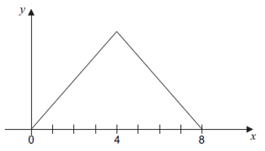
The graph is symmetrical about $x=4$. The range of $g(x)$ is $0≤g\left(x\right)≤12$.
Work out the function $g(x)$.
$$g\left(x\right)=\left\{\begin{matrix}? & 0≤x≤4 \\ ? & 4<x≤8\end{matrix}\right.$$

Exercise 3 – Forming Equations
Finding a suitable function (for which you may always use a straight line) that matches the following criteria.
- Domain is $1≤x<3$. Range $1≤f\left(x\right)≤3$. $f(x)$ is an increasing function.
- Domain is $1≤x≤3$. Range $1≤f\left(x\right)≤3$.
$f(x)$ is a decreasing function.
- Domain is $5≤x≤7$. Range $7≤f\left(x\right)≤11$. $f(x)$ is an increasing function.
- Domain is $5≤x≤7$. Range $7≤f\left(x\right)≤11$. $f(x)$ is a decreasing function.
- Domain is $-4≤x≤7$. Range $4≤f\left(x\right)≤8$. $f(x)$ is a decreasing function.

